“MEDICAL MATTERS”
A Series on Good Health for
Healthy Living!

First Friday of every month at the Library.

Spring Series beginning
February 7, 2020
11:30am-1:00pm
Selma-Dallas County Public Library
Vaughan Community Room
Sack lunch provided to first 25 attendees.
Meet the Docs! Ask the Questions! Get the Facts!
No pre-registration needed!

February 7th
Heart Healthy Habits
May 1st
Your Memory: How to Keep It
April 3rd
Men’s Health: All You Need to Know
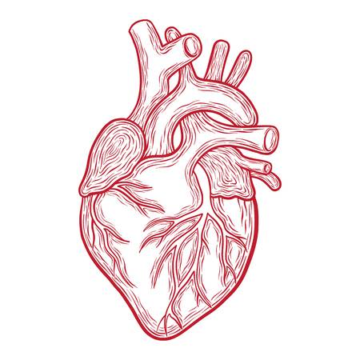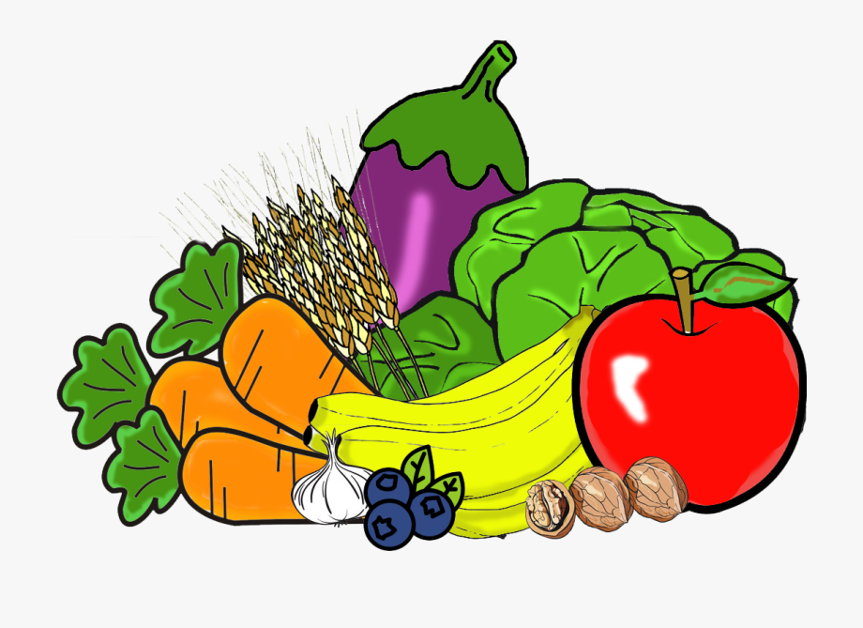
March 6th
Healthy Eating with Diabetes

