

**“MEDICAL MATTERS”**

***A Series on Good Health for***

***Healthy Living!***

***First Friday of every month***

***at the Library.***

**Beginning September 6, 2019  
11:30am-1:00pm Vaughan Room**   
**Sack lunch provided to first 25 attendees.**

**Meet the Docs! Ask the Questions! Get the Facts!**

**No pre-registration needed!**

**Call the Library for more information 874-1725**

September 6th  
 **Healthy Living:**

**Aging Well Healthy Living.**

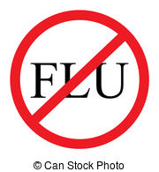

December 6th  
**Emotional Wellness**

November 1st  
 **Flu Season!   
 Be Prepared.**



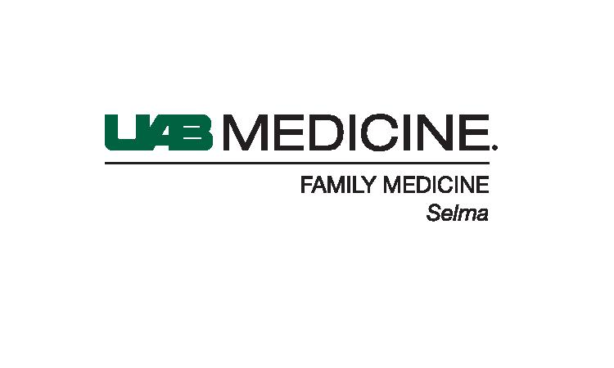

October 4th  
**Women’s Issues:**

**Being Your Best!**